**"Daily Health Navigator – An Expert System for Predicting Daily Calorie Intake and Diet Planning**”

Vamsi Krishna. Rolla

CS 59000 – 05 Expert Systems

Dr. Mohammadreza Hajiarbabi

Table of Contents

1. Introduction
2. Motivation
3. Questions that guided this project
   1. How can we define ourselves healthy?
   2. How can we define that we are physically healthy?
   3. What are factors affecting our body weight?
4. Methodology – Rule based Expert System
   1. Knowledge base
   2. Inference Engine
      1. Linear Regressor
      2. Forward Chaining
   3. User Interface
5. [Limitations](#_Limitations: )
6. [Future Scope](#_Future_Scope: )
7. [References](#_References: )
8. **Introduction:**

In a world where health and well-being take center stage, the significance of maintaining a balanced diet and understanding daily calorie intake cannot be overstated. Introducing "Daily Health Navigator," a revolutionary project designed to empower individuals with personalized insights into their nutritional needs. Leveraging the power of cutting-edge technology, this project utilizes a sophisticated combination of a linear regression model and forward chaining to accurately predict daily calorie intake and facilitate effective diet planning.

**Key Features:**

1. **Predictive Power of Linear Regression:** Daily Health Navigator employs a robust linear regression model to analyze various factors that contribute to an individual's calorie requirements. By considering variables such as age, weight, height, activity level, and other pertinent metrics, the model can predict calorie intake with a high degree of accuracy. This predictive capability serves as the foundation for creating tailored diet plans that align with individual nutritional needs.
2. **Rule based Expert System with Forward Chaining:** To enhance the user experience and provide real-time adaptability, the project incorporates forward chaining. This intelligent algorithm evaluates the user's daily activities, preferences, and nutritional goals to dynamically adjust the recommended diet plan. This ensures that users receive not only accurate predictions but also practical and sustainable dietary suggestions that evolve based on their unique circumstances.
3. **User-Friendly Interface:** Daily Health Navigator's user-friendly chat interface encourages natural and conversational input. Users can engage in dialogue with the Chat-bot, providing details about their daily activities, food preferences, and wellness objectives. This conversational input not only enhances user experience but also allows for a more intuitive and personalized interaction with the application.

Empowering Individuals for Healthier Lifestyles: Daily Health Navigator transcends traditional calorie tracking tools by providing a holistic approach to health and nutrition. By seamlessly integrating advanced prediction models and dynamic diet planning, this project aims to empower individuals to make informed decisions about their dietary habits. Whether pursuing fitness goals, managing weight, or simply adopting a healthier lifestyle, Daily Health Navigator is your reliable companion on the journey to well-being.

Embark on the path to a healthier you with Daily Health Navigator – where precision meets personalization for optimal health and vitality.

1. **Motivation:** Our bodies are dynamic, and the journey to optimal health is diverse for individuals. "Daily Health Navigator" draws inspiration from the belief that the power to understand and manage our weight lies not only in the numbers on a scale but in the patterns and insights hidden within our daily lives. It is a beacon of hope for those navigating the intricate terrain of weight management, offering personalized predictions that extend beyond simple metrics. Recent data reveals that over 42% of the adult population in the United States is affected by obesity, and an additional percentage grapples with underweight issues. The journey toward a healthier weight often involves overcoming numerous hurdles, both physical and emotional. Daily Health Navigator steps in as a companion on this transformative path, providing a personalized solution to empower individuals to reclaim control over their well-being.
2. **Questions that guided this project:**
   1. **How can we define ourselves healthy?**

**Ans)** Health is a holistic concept that encompasses physical, mental, and social well-being. To define ourselves as healthy, we can consider the following aspects:

Physical well-being: This involves having normal bodily functions, being free from illness, and maintaining an appropriate weight.

Mental well-being: Mental health is crucial for overall health. It includes emotional stability, cognitive function, and the ability to cope with stress.

Social well-being: Healthy relationships, a supportive social network, and a sense of community contribute to overall well-being.

* 1. **How can we define that we are physically healthy?**

**Ans)** Physical health can be assessed through various indicators, such as:

Body Mass Index (BMI): A measure of body fat based on height and weight.

Physical fitness: Assessing endurance, strength, flexibility, and overall fitness level.

* 1. **What are factors affecting our body weight?**

**Ans)** several factors contribute to body weight, including:

Diet and nutrition: The types and amounts of food consumed play a significant role.

Physical activity: The level of exercise and daily activity influences weight.

Metabolism: The body's ability to process and utilize energy from food.

Genetics: Genetic factors can affect metabolism and body composition.

**Conclusion:** Considering the answers to the three questions, it becomes evident that physical health and body weight are closely related. To predict daily calorie intake accurately, it is essential to incorporate features that reflect an individual's physical well-being and body weight. Therefore, choosing physical measurements like height, weight, age, and potentially other relevant metrics into your model is a reasonable and holistic approach. These measurements can serve as valuable indicators for predicting calorie needs and suggesting appropriate dietary recommendations for maintaining or achieving a healthy weight.

1. **Methodology:** Rule Based Expert System

The methodology for the "Daily Health Navigator" project combines machine learning and expert systems domains. Leveraging a linear regressor model from machine learning, the system predicts daily calorie intake based on user features like height, weight, and age. Simultaneously, the incorporation of forward chaining in expert systems enables dynamic and real-time updates, adapting predictions as new health metrics are provided. This dual approach ensures accurate and personalized recommendations, blending the predictive power of machine learning with the adaptive logic of expert systems. The seamless integration of these methodologies enhances the system's efficacy in guiding users towards healthier daily dietary choices.

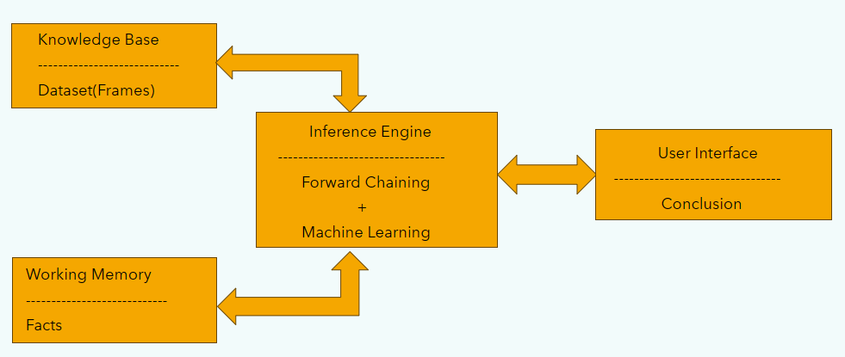

*Fig 1 – Rule based Expert System*

* 1. **Knowledge Base:** Datasets
* https://www.kaggle.com/datasets/vechoo/diet-plan-recommendation - Used to Predict Calories
* https://www.kaggle.com/datasets/niharika41298/nutrition-details-for-most-common-foods - Used to suggest Food items
  1. **Inference Engine:** Linear Regressor + Forward Chaining
     1. **Linear Regressor:** Linear regression is a versatile and widely used machine learning algorithm that aims to establish a linear relationship between a dependent variable and one or more independent variables. In the context of your project, where the goal is to predict daily calorie intake, linear regression analyzes historical data to learn the patterns and correlations between features like height, weight, and age and the corresponding calorie consumption. The algorithm then creates a linear equation that best fits this relationship, enabling accurate predictions of calorie intake for individuals based on their specific characteristics. Linear regression's simplicity, interpretability, and effectiveness make it an ideal choice for tasks where the goal is to predict continuous outcomes.

Training a Linear Regressor model to predict calories:

1. Data Collection: Gather a dataset that includes relevant features such as height, weight, age, and corresponding daily calorie intake.
2. Data Preprocessing: Handle missing data and outliers. Normalize or standardize numerical features to ensure consistent scaling.

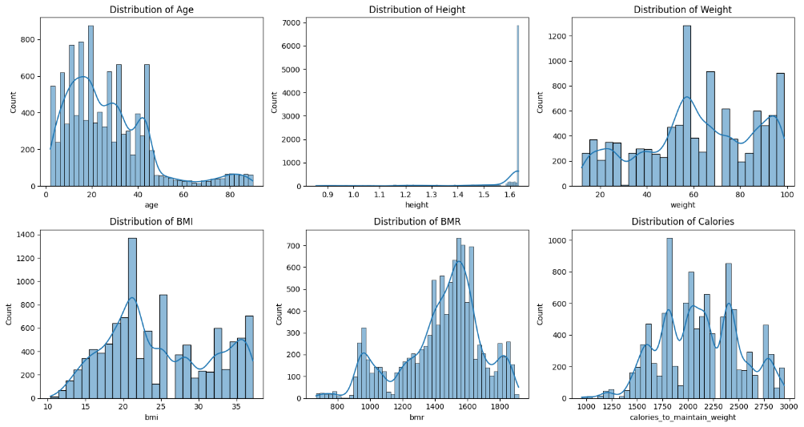

*Fig 2 – Distribution Chart of the features*

1. Feature Selection: Identify and select features that have a significant impact on calorie intake prediction.

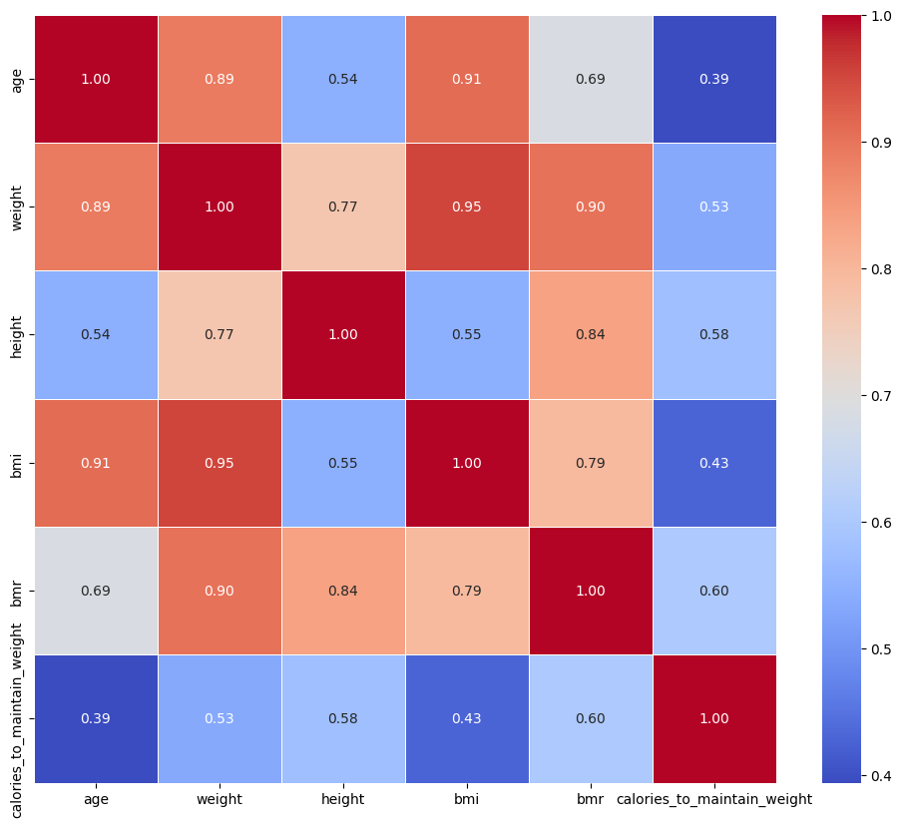

*Fig 3 – Correlation Matrix*

1. Splitting the Data: Divide the dataset into training and testing sets to assess the model's performance.
2. Training the Model: Use the training data to fit the linear regression model. The model learns the coefficients that minimize the difference between predicted and actual calorie intake.
3. Model Evaluation: Evaluate the model's performance on the testing set using Mean Squared Error (MSE) which gave me 0.98.
4. Predictions: Use the trained model to make predictions on new or unseen data.
   * 1. **Forward Chaining:** Forward chaining is a reasoning strategy employed in expert systems; a branch of artificial intelligence designed to emulate human decision-making processes. In forward chaining, the system starts with known facts and iteratively applies rules to deduce new information or make predictions. In the context of your project, forward chaining adds a dynamic and adaptive element to the daily health prediction system. As new health metrics, such as updated weight or additional activity data, become available, forward chaining allows the system to continuously update its predictions and recommendations in real time. This flexibility and responsiveness make forward chaining particularly well-suited for expert systems where the information landscape evolves, ensuring that the "Daily Health Navigator" can provide accurate and personalized guidance based on the most current user data.

**Rules:**

Rule1: height check and bring into single unit

Rule2: age check and throw error

Rule3: gender check and throw error

Rule4: weight check and bring into single unit

Rule5: activity level check and find the associated numeric value

Rule6: calculate bmi using formula

Rule7: check the bmi category based on bmi index

Rule8: calculates the ideal weight

Rule9: check weight difference between current weight and ideal weight

Rule10: check the pace of goal fulfilment

Rule11: estimating the goal completion

Rule12: get the proportionality based on pace and activity level

Rule13: calories intake prediction using model

Rule14: food items suggestion based on calories intake

* 1. **User Interface:** React Chat-bot

The "Daily Health Navigator" project seamlessly integrates a React Chabot as its user interface, revolutionizing the data collection and health guidance process. Users engage in a conversational interface to effortlessly input health metrics such as height, weight, and age, while the Chat-bot, driven by a Linear Regressor model and forward chaining, predicts daily calorie intake in real-time. This intelligent system goes beyond predictions, providing instant, personalized dietary suggestions and dynamically adjusting meal plans based on user feedback and evolving health metrics. The React chat-bot fosters user engagement, making health management interactive and accessible, as it guides individuals through a holistic approach to maintaining a balanced lifestyle by combining machine learning for precise predictions and expert system logic for adaptive and responsive decision-making.

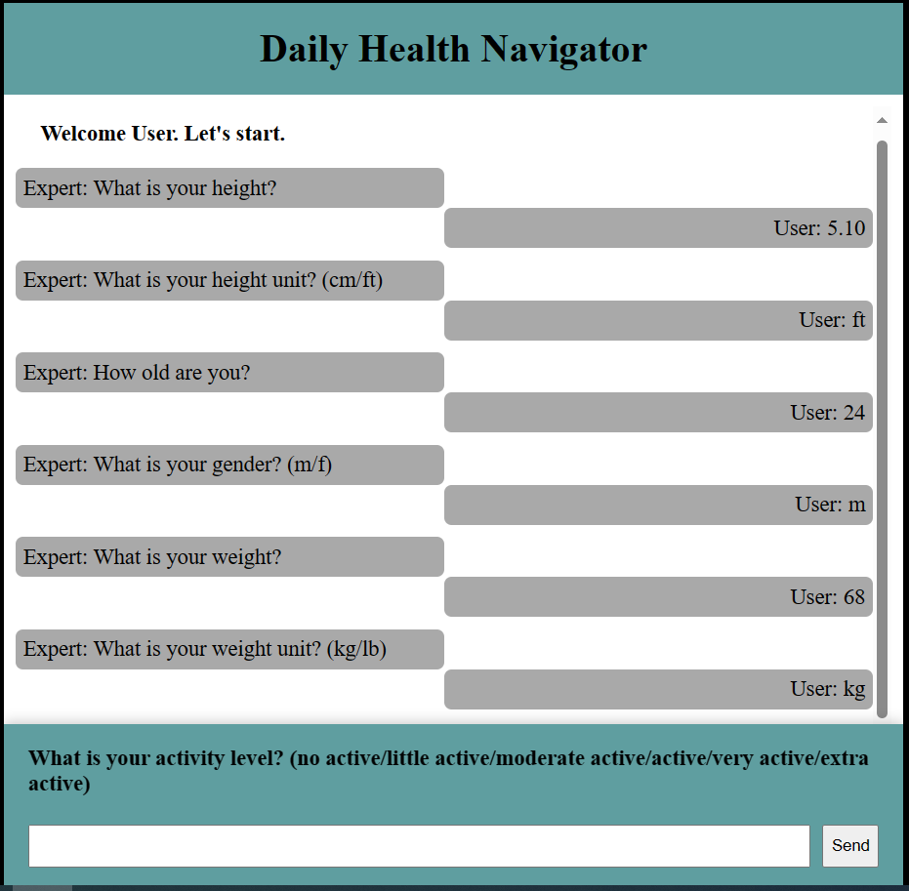

*Fig 4– Chat-bot User Interface*

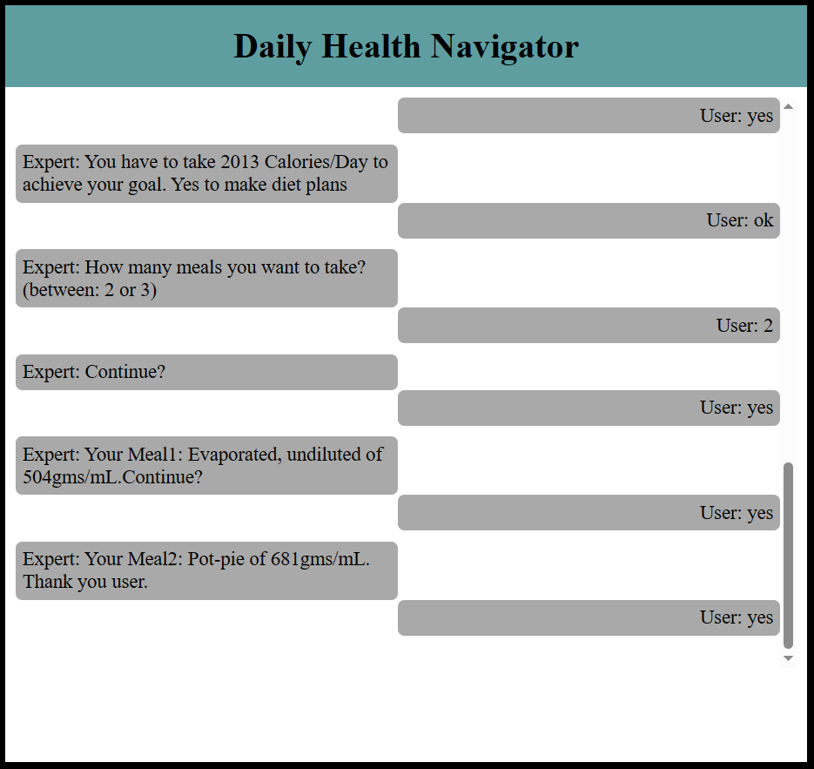

*Fig 5 – Calories predicted, and Food items suggested*

1. **Limitations:**
2. Age Limitation: Predictions exclude users below the age of 13 due to a lack of sufficient data within this age group.
3. Gender Restriction: The system refrains from predicting for users with genders outside commonly recognized categories, as there is no available data or applicable BMR calculation formulas for such genders.
4. Strict Input Types: Input types are strictly restricted to prevent errors or application halts, ensuring that the system functions reliably without encountering issues caused by incorrect data types.
5. Focus on Calorie Suggestions: The system exclusively suggests food items based on calorie intake, concentrating its functionality on precise dietary recommendations within the scope of calorie predictions.

# **Future Scope:**

1. Exercise Recommendations: Future iterations of the "Daily Health Navigator" could expand its functionality to include personalized exercise suggestions for weight gain or loss, offering users a comprehensive approach to health management by integrating physical activity recommendations.
2. Enhanced Food Item Suggestions: The system's capabilities can be augmented by considering additional factors such as food allergies and specific medical conditions in suggesting personalized food items. This expansion would cater to a wider range of user needs, accommodating diverse health considerations and preferences.
3. User Interface Enhancement: Future development could focus on improving the user interface, ensuring a more intuitive and visually appealing experience. Incorporating user feedback and the latest design principles could enhance usability, making the "Daily Health Navigator" even more accessible and engaging for users.

# **References:**

* Lecture Notes.
* Expert systems: design and development by Durkin, John. Macmillan Publishing Company (1994).
* https://www.kaggle.com/
* https://www.geeksforgeeks.org/ml-linear-regression/
* https://chat.openai.com/